# Lab #03(a)

**Data Transmission**

To Study about basics of data transmission media and its type.

**THEORY:**

**Transmission Media**

Transmission media that are used to convey information usually moves from one network device to another. The transmission medium is usually free space, metallic cable, or fiber-optic cable.

In telecommunications, transmission media can be divided into two broad categories: guided and unguided. Guided media include twisted-pair cable, coaxial cable, and fiber-optic cable.

Unguided medium is free space i.e. wireless trans-mission occurs through the atmosphere, outer space, or water.

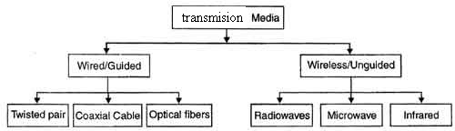

## Guided Transmission Media

The three guided media commonly used for data transmission are twisted pair, coaxial cable, and optical fiber. A signal traveling along any of these media is directed and contained by the physical limits of the medium. Twisted-pair and coaxial cable use metallic (copper) conductors that accept and transport signals in the form of electric current. Optical fiber is a cable that accepts and transports signals in the form of light.

## Twisted Pair

The most common guided transmission medium for both analog and digital signals is twisted pair. The least expensive than the other commonly used guided transmission media (coaxial cable, optical fiber) and most widely used guided transmission medium.

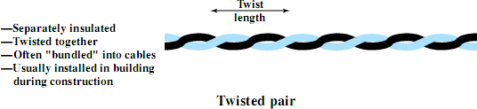

A twisted pair consists of two insulated copper wires arranged in a regular spiral pattern. A wire pair acts as a single communication link. Typically, a number of these pairs are bundled together into a cable by wrapping them in a tough protective sheath. The twisting tends to decrease the crosstalk interference between adjacent pairs in a cable.

Twisted pair comes in two varieties:

## Unshielded Twisted Pair (UTP) Cable :

Unshielded twisted pair is the most common kind of copper telephone wiring. Twisted pair is the ordinary copper wire that connects home and many business computers to the telephone company. To reduce crosstalk or electromagnetic induction between pairs of wires, two insulated copper wires are twisted around each other.

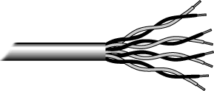

UTP Cables

The quality of UTP may vary from telephone-grade wire to extremely high-speed cable. The cable has four pairs of wires inside the jacket. Each pair is twisted with a different number of twists per inch to help eliminate interference from adjacent pairs and other electrical devices. The EIA/TIA (Electronic Industry Association/Telecommunication Industry Association) has established standards of UTP and rated five categories of wire.

|  |  |
| --- | --- |
| Type | Use |
| Category 1 | Voice Only (Telephone Wire) |
| Category 2 | Data to 4 Mbps (LocalTalk) |
| Category 3 | Data to 10 Mbps (Ethernet) |
| Category 4 | Data to 20 Mbps (16 Mbps Token Ring) |
| Category 5 | Data to 100 Mbps (Fast Ethernet) |

## Unshielded Twisted Pair Connector:

The standard connector for unshielded twisted pair cabling is an RJ-45 connector. This is a plastic connector that looks like a large telephone-style connector .A slot allows the RJ-45 to be inserted only one way. RJ stands for Registered Jack, implying that the connector follows a standard borrowed from the telephone industry. This standard designates which wire goes with each pin inside the connector.

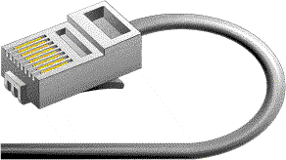

RJ45 Connector

## Shielded Twisted Pair (STP) Cable :

Although UTP cable is the least expensive cable, it may be susceptible to radio and electrical frequency interference (it should not be too close to electric motors, fluorescent lights, etc.). If you must place cable in environments with lots of potential interference, or if you must place cable in extremely sensitive environments that may be susceptible to the electrical current in the

UTP, shielded twisted pair may be the solution. Shielded cables can also help to extend the maximum distance of the cables.

Shielded twisted pair cable is available in three different configurations:

1. Each pair of wires is individually shielded with foil.
2. There is a foil or braid shield inside the jacket covering all wires (as a group).
3. There is a shield around each individual pair, as well as around the entire group of wires (referred to as double shield twisted pair).

## Coaxial Cable:

A type of wire that consists of a center wire surrounded by insulation and then a grounded shield of braided wire. The shield minimizes electrical and radio frequency interference.

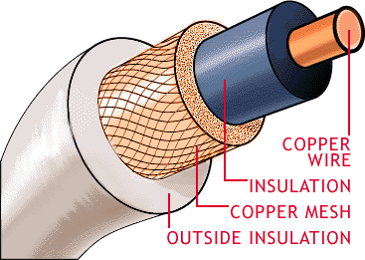

Coaxial Cable

Coaxial cabling is the primary type of cabling used by the cable television industry and is also widely used for computer networks, such as Ethernet. Although more expensive than standard telephone wire, it is much less susceptible to interference and can carry much more data.

The two types of coaxial cabling are thick coaxial and thin coaxial.

Thin coaxial cable is also referred to as thin net. 10Base2 refer to the specifications for thin coaxial cable carrying Ethernet signals. The 2 refer to the approximate maximum segment length being 200 meters. In actual fact the maximum segment length is 185 meters. Thin coaxial cable is popular in school networks, especially linear bus networks.

Thick coaxial cable is also referred to as thick net. 10Base5 refer to the specifications for thick coaxial cable carrying Ethernet signals. The 5 refer to the maximum segment length being 500 meters. Thick coaxial cable has an extra protective plastic cover that helps keep moisture away from the center conductor. This makes thick coaxial a great choice when running longer lengths

in a linear bus network. One disadvantage of thick coaxial is that it does not bend easily and is difficult to install.

## Coaxial Cable Connectors:

The most common type of connector used with coaxial cables is the Bayone-Neill-Concelman (BNC) connector. Different types of adapters are available for BNC connectors, including a T- connector, barrel connector, and terminator. Connectors on the cable are the weakest points in any network. To help avoid problems with your network, always use the BNC connectors that crimp, rather than screw, onto the cable.

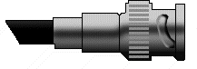

## Fiber Optic Cable:

BNC Connector

Instead of insulated metal wires transmitting electrical signals, fiber optic network cables work using strands of glass and pulses of light. These network cables are bendable despite being made of glass. They have proven especially useful in wide area network (WANs)installations where long distance underground or outdoor cable runs are required and also in office buildings where a high volume of communication traffic is common.

Two primary types of fiber optic cable industry standards are defined – single-mode (100BaseBX standard) and multimode (100BaseSX standard). Long-distance telecommunications networks more commonly use single-mode for its relatively higher bandwidth capacity, while local networks typically use multimode instead due to its lower cost.



Facts about fiber optic cables:

* + Outer insulating jacket is made of Teflon or PVC.
  + Kevlar fiber helps to strengthen the cable and prevent breakage.
  + A plastic coating is used to cushion the fiber center.
  + Center (core) is made of glass or plastic fibers.

## Fiber Optic Connector :

Most fiber optic connectors are plugs or so-called male connectors with a protruding ferrule that holds the fibers and aligns fibers for mating. They use a mating adapter to mate the two connector ferrules that fits the securing mechanism of the connectors (bayonet, screw-on or snap- in.) The ferrule design is also useful as it can be used to connect directly to active devices like LEDs, VCSELs and detectors.

|  |  |  |
| --- | --- | --- |
| **Specificatio n** | **Cable Type** | **Maximum length** |
| 10BaseT | Unshielded Twisted Pair | 100 meters |
| 10Base2 | Thin Coaxial | 185 meters |
| 10Base5 | Thick Coaxial | 500 meters |
| 10BaseF | Fiber Optic | 2000 meters |

## Installing Cable - Some Guidelines:

When running cable, it is best to follow a few simple rules:

* + Always use more cable than you need.
  + Test every part of a network as you install it. Even if it is brand new, it may have problems that will be difficult to isolate later.
  + Stay at least 3 feet away from fluorescent light boxes and other sources of electrical interference.
  + If it is necessary to run cable across the floor, cover the cable with cable protectors.
  + Label both ends of each cable.
  + Use cable ties (not tape) to keep cables in the same location together.

# Lab # 03(b)

**Cables and Connectors**

To Study about basics of straight through and cross-over cable and its connector.

## THEORY STRAIGHT CABLE:

Straight cable usually uses to connect different type of devices.

### EXAMPLES:

* Connect a computer to a switch/hub's normal port.
* Connect a computer to a cable/DSL modem's LAN port.
* Connect a router's WAN port to a cable/DSL modem's LAN port.
* Connect a router's LAN port to a switch/hub's uplink port. (normally used for expanding network)
* Connect 2 switches/hubs with one of the switch/hub using an uplink port and the other one using normal port.

## CROSS CABLE:

Cross cable usually used to connect same type of devices.

EXAMPLES:

* Connect 2 computers directly.
* Connect a router's LAN port to a switch/hub's normal port. (normally used for expanding network.)
* Connect 2 switches/hubs by using normal port in both switches/hubs.

## Examples

Sir Syed University of Engineering and Technology

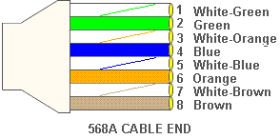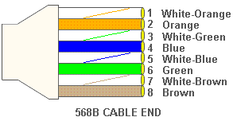(Department of computer Science & Information Technology) Page 7

## To Make Cables:

### STRAIGHT THROUGH CABLES:

**Requirements:** Two RJ45 Connectors, Crimping tool & CAT 5 cable of desired length(less than 250 meters).

## Steps:

1. Measure out the distance between the two devices you want to connect with the straight through cable. Acquire a length of Cat5 Ethernet cable that is at least one foot longer than the measured distance to account for any mistakes made while cutting the cable.
2. Place one inch of either end of the Cat5 cable into the stripping hole in the crimp tool. Squeeze the handles of the crimp tool slightly to cut into the outer covering of the Cat5 cable.
3. Pull the crimp tool away from you to remove the outer covering from the inner strands of cable. Untwist each of the colored cable strands.
4. Arrange the colored strands, from left to right, in the correct order for a straight through cable. Line-up the strands in the order of white/orange, orange, white/green, blue, white/blue, green, white/brown, and then brown.
5. Snip off the ends of the colored wires with the cutting edge of the crimp tool to make sure they are all uniform length. Insert the colored cables into the plastic RJ-45 connector.
6. Place the RJ-45 connector into the crimping hole on the crimp tool. Squeeze the crimp tools handles all the way down to crimp the RJ-45 connector onto the Cat5 cable.
7. Repeat the process of stripping, cutting, arranging, and crimping the other end of the Cat5 Ethernet cable.

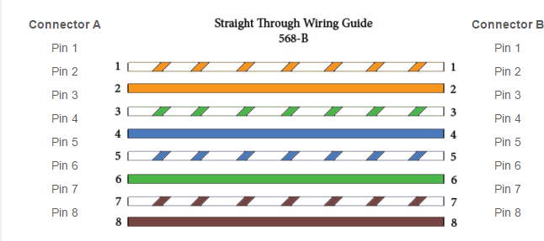

## CROSS CABLES:

1. Find a standard Ethernet cable you don't use for anything**.**
2. Towards one end of the cable, cut open a slit a few inches long. Be careful not to damage the wiring inside the cable or cut yourself.
3. Peel back and remove the cable casing. This will leave the inner wiring exposed. Examine how the wiring is twisted together and note the colors of the wires.
4. With the wires cut, work now one-by-one.
5. On Side "A" we will call it, connect the end to the end on Side "B".
6. You now have one step of your crossover wire completed.
7. Now repeat the process with the final two wires.
8. Twist the wires together and fix with tape.
9. Join the remaining wires.
10. Note the direction that the wiring in the cable case is twisting.

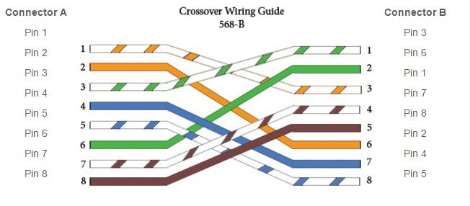

## UNSHIELDED TWISTED PAIR CABLE:

Unshielded twisted pair is the most common kind of copper telephone wiring. Twisted pair is the ordinary copper wire that connects home and many business computers to the telephone company.

* Consists of 4 pairs (8 wires) of insulated copper wires typically about 1 mm thick.
* The wires are twisted together in a helical form.
* Twisting reduces the interference between pairs of wires.
* High bandwidth and High attenuation channel.
* Flexible and cheap cable.
* Category rating based on number of twists per inch and the material used.
* CAT 3, CAT 4, CAT 5, Enhanced CAT 5 and now CAT 6.

## CAT 5:

CAT 5 is an Ethernet network cable standard defined by the Electronic Industries Association and Telecommunications Industry Association (commonly known as EIA/TIA). CAT5 is the fifth generation of twisted pair Ethernet technology and the most popular of all twisted pair cables in use today.

* **Network support** - CAT 5 cable will support 10/100 Ethernet. That is, Ethernet and Fast Ethernet.
* **Less cross talk** - Cross talk is the electrical interference that result’s when one wire's signal effect’s another wire's signal.
* **Bandwidth** - This is directly related to network support, in the sense that the bandwidth is the information-carrying capacity of a system. The greater the bandwidth, the greater the information-carrying capacity in a given period of time.

## CONNECTOR (RJ 45):

A registered jack (RJ) is a standardized physical network interface for connecting telecommunications or data equipment. The physical connectors that registered jacks use are mainly of the modular connector and 50-pin miniature ribbon connector types. The most common twisted-pair connector is an 8-position, 8-contact (8P8C) modular plug and jack commonly referred to as an RJ45 connector.

A slot allows the RJ-45 to be inserted only one way, implying that the connector follows a standard borrowed from the telephone industry. This standard designates which wire goes with each pin inside the connector.

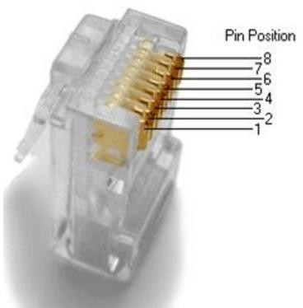

## NETWORK CABLE TOOLS:

* Cable Jacket Stripper.
* [CI-KIT](https://www.siemon.com/e-catalog/ECAT_GI_page.aspx?GI_ID=tt_ci-kit)
* [CI-KIT2](https://www.siemon.com/e-catalog/ECAT_GI_page.aspx?GI_ID=tt_ci-kit2)
* [CPT](https://www.siemon.com/e-catalog/ECAT_GI_page.aspx?GI_ID=tt_cpt)
* [CPT-WEB](https://www.siemon.com/e-catalog/ECAT_GI_page.aspx?GI_ID=tt_cpt-web)
* [Cutter](https://www.siemon.com/e-catalog/ECAT_GI_page.aspx?GI_ID=tt_cutter)
* [Electrician's Scissors](https://www.siemon.com/e-catalog/ECAT_GI_page.aspx?GI_ID=tt_electricians-scissors)
* [MAX TurboTool](https://www.siemon.com/e-catalog/ECAT_GI_page.aspx?GI_ID=tt_max-turbotool)
* [Palm Guard](https://www.siemon.com/e-catalog/ECAT_GI_page.aspx?GI_ID=tt_palm-guard)
* [Probe-Pic](https://www.siemon.com/e-catalog/ECAT_GI_page.aspx?GI_ID=tt_probe-pic)
* [PT-908 Crimp Tool](https://www.siemon.com/e-catalog/ECAT_GI_page.aspx?GI_ID=tt_pt-908-crimp-tool)
* [RG6 F-Type Termination Tool](https://www.siemon.com/e-catalog/ECAT_GI_page.aspx?GI_ID=tt_coaxial-crimp-tool)
* [S110/S210 Multi-Pair Termination Tool](https://www.siemon.com/e-catalog/ECAT_GI_page.aspx?GI_ID=tt_s110-s210-multi-pair-termination-tool)
* [S814 Impact Tool](https://www.siemon.com/e-catalog/ECAT_GI_page.aspx?GI_ID=tt_s814-impact-tool)
* [TERA Cable Preparation Tool](https://www.siemon.com/e-catalog/ECAT_GI_page.aspx?GI_ID=tt_tera-cable-preparation-tool)
* [XLR8 Fiber Termination Kit](https://www.siemon.com/e-catalog/ECAT_GI_page.aspx?GI_ID=fi_xlr8-fiber-termination-kit)
* [Z-MAX Z-TOOL](https://www.siemon.com/e-catalog/ECAT_GI_page.aspx?GI_ID=tt_z-tool)

**EXERCISES**

* 1. What is the significance of twisting in twisted pair copper wires?
  2. What is the difference between unshielded and shielded twisted pair wires?
  3. What is the difference between guided and unguided medium?
  4. What are the application of fiber optics,twisted pair and coaxial cables?
  5. What is the position of transmission media in OSI model?
  6. Just name the components of optical fiber cables?
  7. What are the usage of straight and cross over cables?